**Carbon Reduction Plan**

**Supplier Name:** Seven Steps Healthcare Limited

**Publication Date:** 02/07/2024

**Commitment to Achieving Net Zero**

Seven Steps Healthcare Limited is committed to achieving Net Zero emissions by 2050.

**Baseline Emissions Footprint**

Baseline emissions are a record of the greenhouse gases that have been produced in the past and were produced before the introduction of any strategies to reduce emissions. Baseline emissions are the reference point against which emissions reduction can be measured.

**Baseline Year:** 2024 (01/01/2024 to 31/12/2024)

**Additional Details Relating to the Baseline Emissions Calculations:** As this is our first carbon footprint assessment, the baseline year emissions will be used as the reference point. The methodology for measuring our carbon footprint aligns with the Greenhouse Gas Protocol and the BEIS Environmental Reporting Guidelines. The calculations were completed using the UK Government emissions factors.

**Baseline Year Emissions**

|  |  |
| --- | --- |
| Emissions | Total (tCO2e) |
| Scope 1 | 50.00 |
| Scope 2 | 85.00 |
| Scope 3 |  |
| - Upstream T&D | Not relevant (Seven Steps Healthcare provides social care services rather than goods; thus, transportation and distribution of goods are not relevant) |
| - Waste | 0.15 |
| - Business Travel | 400.00 |
| - Employee Commuting | 550.00 |
| - Downstream T&D | Not relevant (same reason as upstream T&D) |
| Total Emissions | **1085.15** |

**Current Emissions Reporting**

**Reporting Year:** 2024

**Emissions (Total tCO2e)**

**Current Emissions Reporting**

|  |  |
| --- | --- |
| Emissions | Total (tCO2e) |
| Scope 1 | 50.00 |
| Scope 2 | 85.00 |
| Scope 3 |  |
| - Upstream T&D | Not relevant |
| - Waste | 0.15 |
| - Business Travel | 400.00 |
| - Employee Commuting | 550.00 |
| - Downstream T&D | Not relevant |
| Total Emissions | **1085.15** |

**Emissions Reduction Targets**

To continue our progress towards achieving Net Zero by 2050, we have adopted the following carbon reduction targets:

* Recycling
* Digitalised Timesheets
* Electric Vehicles
* Offsetting

We project that carbon emissions will decrease over the next five years to 465 tCO2e by 2029. This is a reduction of approximately 65% from the 2024 baseline. Carbon offsetting or technology such as carbon capture and storage will be deployed to achieve the difference between actual and net zero carbon.

**Emissions Reduction Graph**

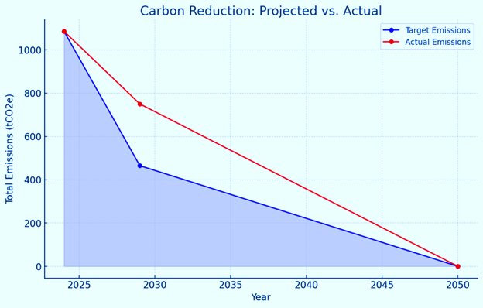

**Carbon Reduction Projects**

The following environmental management measures and projects have been completed or implemented since the 2024 baseline:

* Reducing energy used by office equipment
* Installation of LED lighting in office properties
* Implemented energy-saving routine for office equipment (e.g., setting up computers and monitors to automatically switch off when users are away from their desks for more than 10 minutes)
* Raised employee awareness about office equipment efficiency
* Implemented an office energy equipment policy
* Encouraged the use of public transportation and carpooling among staff
* Encouraging staff to use video conferencing where possible
* Upgraded equipment management systems to reduce energy usage (including power-saving settings on computers and monitors)
* Set printers to the most energy-efficient mode allowing only black and white and double-sided printing and educated staff to avoid unnecessary printing
* Completed a sustainability opportunity assessment to build and implement our corporate sustainability strategy including environmental social and economic pillars

**Future Measures**

In the future, we plan to implement further measures such as:

* Reducing power consumption focused on air conditioning, building fabric insulation, space heating, ventilation, and hot water
* Feasibility study for onsite renewable energy sources through solar panel installation
* Purchase of 100% renewable energy
* IT systems optimisation for energy efficiency
* Transition to zero-emission vehicles
* Requiring suppliers to report their carbon footprint data to improve accuracy and support our net zero goal
* Evaluating all purchased products for more efficient use such as reducing single-use plastic, switching from disposable to reusable equipment, and using low-carbon substitutions
* Active management and reduction of emissions from staff travel
* Encouraging low-carbon commuting options for staff

**Declaration and Sign-off**

This Carbon Reduction Plan has been completed following PPN 06/21 and associated guidance and reporting standards for Carbon Reduction Plans. Emissions have been reported and recorded by the published reporting standard for Carbon Reduction Plans and the GHG Reporting Protocol corporate standard and use the appropriate Government emission conversion factors for greenhouse gas company reporting. Scope 1 and 2 emissions have been reported following SECR requirements and the required subset of Scope 3 emissions have been reported following the published reporting standards for Carbon Reduction Plans and the Corporate Value Chain (Scope 3) Standard. This Carbon Reduction Plan has been reviewed and signed off by the board of directors (or equivalent management body).

**Signed on behalf of the Supplier:**



**Seven Steps Healthcare Limited**

Victor Zano  
Director  
Date: 02/07/2024